Government System of Italy

November 2014

Vol. 1 Issue 1

1. President Giorgio Napolitano

By: Kyrsten Meese

The Parliament:

The Italian parliament is a bicameralism legislature that consists of two houses: the Chambers of Deputies and the Senate of the Republic. The two houses perform identical functions of making laws for the country. Both Houses are elected every five years. The only difference between the two houses is the membership and the rules for the election of the members. There are 630 deputies that must be the age of at least 25. There are 315 elected senators that must be at least 40 years of age. The Senate also includes life senators.

Judiciary of Italy:

The Italian judicial system consists of a series of courts and a body of judges who are public officials and are Italian citizens. Once appointed, judges serve for life and cannot be removed without specific disciplinary proceedings conducted in due process before the Consiglio Superiore della Magistratura. The Italian judiciary structure is divided into three parts. There is civil law, criminal law and labour law. The highest court is he Corte di Cassazione.

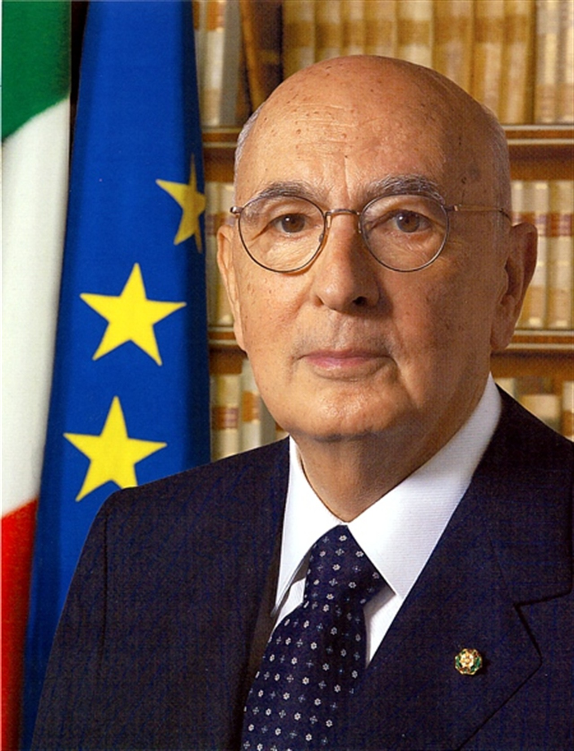

Elected May 2006

Background

On June 2, 1946, many Italians voted in a referendum to abolish the monarchy and for the country to become a republic. Italy is officially known as the Republica Italiana or the Italian Republic. The country’s official religion is Roman Catholicism.

There are twenty regions in Italy that are divided into 110 provinces. These provinces are then divided into eight thousand, one hundred communes.

Italy is a Parliamentary Republic. Its political system is based on the Constitution of the Italian Republic. Power is divided among the executive, the legislative and judicial branches. The President and the Prime Minister are the important roles within the Italian government.

The president –

The president is elected by an electoral college. He serves a seven-year term. He appoints the executive cabinet, serves as president of the judiciary and is also commander-in-chief of the armed forces. The president is able to send messages to the parliament and authorize the introduction of the new bills by the government. He is also able to appoint states officials, makes war declarations as approved by the Parliament and ratify international treaties.

2. Prime Minster Matteo Renzi

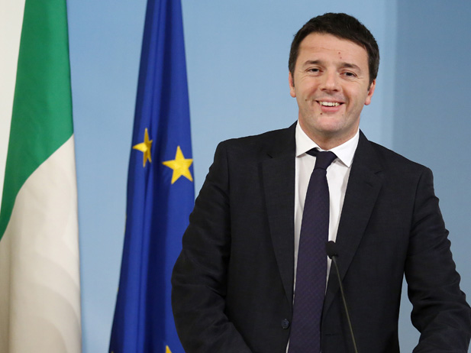

Elected Feb. 2014

The Prime Minister -

The prime minister is appointed by the president with the approval of the parliament. He serves a seven-year term. The prime minister is the President of the Council of Ministers, which holds effective executive power. However, he must receive a vote of approval in order for it to execute most political activities. He is a member of the cabinet and is able to nominate a list of cabinet ministers to be appointed by the president. The prime minister’s job also includes countersigning of all the legislative instruments which have the force of law that is signed by the president.